**Context of Use and User Interface Requirements**

* 1. **COS70004 – User Centred Design**
  2. **Deliverable – 2**
  3. *August 30, 2024*
  4. **Team Code: - Tuesday 08:30 batch - CLO3 T03**
  5. **Student Name Student ID**

Arun Ragavendhar Arunachalam Palaniyappan 104837257

Marcus Tran 105149160

Le Yen Chi Pham 103430040

Tserennadmid Battulga 103830530

# **Acknowledgement of Country**

To the Traditional Custodians of the land where we live and work, we, Marcus Tran, Le Yen Chi Pham, Arun Ragavendhar Arunachalam Palaniyappan, and Tserennadmid Battulga, sincerely thank you for your cooperation in this endeavour. We appreciate their ongoing linkages to the land, rivers, and communities and pay tribute to their Elders, both past and present. Today, we also honour all Aboriginal and Torres Strait Islander peoples.

# **Contribution Statements**

|  |  |  |
| --- | --- | --- |
| **Name** | **Role** | **Contribution** |
| Arun Ragavendhar Arunachalam Palaniyappan | Team Leader, Researcher, Planner, Designer, Developer and Technical Specialist | Background, Context of Use, User Persona Model, User Requirements, Discussion about user persona model, document formatting and proofreading |
| Le Yen Chi Pham | Team Organizer, Researcher, Developer | HTI Task Model, User Requirements, Discussion about HTI model, document formatting |
| Marcus Tran | Researcher, Editor | Flow Model, Discussion and Conclusion |
| Tserennadmid Battulga | Researcher, Team contributor | Executive Summary, Environment Model, User Requirements, Discussion |

# **Executive Summary**

This project provides an overview of a wandering detection app designed to assist caregivers of people with dementia. Wandering poses a significant risk for people with dementia, potentially leading them into dangerous situations. To address this challenge, the proposed app can enable caregivers to track the location and monitor the health status of people with dementia in real time through a connected smartwatch.

Caregivers, who are the primary users, are often elderly and may have limited experience with technology. Therefore, the app is designed to be simple and easy to use. The secondary users are the people with dementia, who are more likely to forget carrying a phone but can consistently wear a smartwatch. Tertiary users include family members, healthcare providers, and emergency personnel, who can quickly respond to alerts.

The app’s main requirements include real-time location monitoring, the ability to set safe zones with alerts if a user exits these areas, the capability to make phone calls through the watch, monitoring of the watch's battery level, access to health information, and automatic notifications. It also features an interface that is user-friendly for elderly users and supports multiple languages.

The app also focuses on data privacy and security, along with providing reliable, in-time tracking and a user-friendly interface with emergency management features. The goal is to enhance the safety and well-being of people with dementia while offering caregivers valuable support and peace of mind.

## Table of Contents

**Acknowledgement of Country** 2

**Contribution Statements** 2

**Executive Summary** 3

Table of Contents 4

**1. Background** 5

**2. Context Of Use** 5

2.1 Primary Users 5

2.2 Secondary Users 6

2.3 Tertiary Users 6

2.4 Environmental Factors 7

**3. Models** 8

3.1 User Persona Model 8

3.2 Flow Model 9

3.3 Task Model 10

3.4 Environmental Model 11

**4 User Requirements** 12

**5 Discussion and Conclusion** 14

5.1 Discussion 14

5.2 Conclusion 15

**6. Appendix** 15

6.1 List of Figures 15

**7. References** 16

# **1. Background**

Globally, 47 million individuals live with dementia, and this figure is anticipated to climb to 131 million by 2050 **(Alzheimer’s Disease International, 2016)**. There are several varieties of dementia, including Alzheimer's, Vascular, Lewy Body, Parkinson's disease, and Frontotemporal Dementia, each with its own set of cognitive and behavioural problems. Carers for patients with dementia can face challenging dynamics, especially when they are family members. The issue is worsened further by the physical and psychological strain that carers may face because of violent behaviours displayed by people with dementia **(Wang et al., 2013)**. This emphasises the critical need for helpful tools to help carers fulfil their obligations.

This project attempts to use innovative technologies to help carers monitor and manage people living with dementia. The main idea is to provide the person with a wristwatch with a SIM card and GPS, allowing carers to follow their whereabouts and check their vital signs using a wandering detection app installed and setup on their mobile devices **(Lin et al., 2014).** The software and wristwatch work together to create a "safe zone" by analysing GPS data, allowing for real-time tracking and position of the individual with dementia **(Qiang et al., 2018)** and alerting the carer if the person living with dementia wanders away from a dedicated safe zone**.** Data mining techniques are also to be used to discover movement patterns and abnormalities, which aids in the prediction of wandering behaviour and improves carer monitoring **(Lin et al. 2012).**

Despite technological developments, ethical considerations like privacy, fairness, and interconnectedness are frequently disregarded. While carers prioritise accurate tracking, the people living with dementia may believe their privacy is compromised **(Robinson et al., 2007).** Developers can address ethical concerns during development, but the ultimate obligation is on the end users **(Howes et al., 2024).**

# **2. Context Of Use**

## 2.1 Primary Users

The wandering detection app is mainly meant to be used by caregivers, who are usually spouses or close family members of people with dementia. These caregivers are often elderly individuals who may lack familiarity with the latest technologies. They require an app that is accessible, with an easy-to-use interface that allows them to easily watch over their loved ones' location, movements, and vital signs.

The interface is to be built with simplicity in mind, with clear instructions, big, easily recognisable icons, and minimal navigational steps required to access important services. The interface should be designed for less tech-savvy users, but it should also have advanced features for younger or more tech-comfortable family members. However, the focus of the design is to be accessible for people who are not familiar with digital technology.

**Goals of Primary Users:**

* Need to keep individuals with dementia safe by watching over them in real time and preventing them from wandering into unsafe areas.
* Need a simple and easy to use user interface.
* Require quick access to important information like location and health level indicators of the person with dementia.
* Need quick alert notifications if a person with dementia wanders outside marked safe zones or if their vital signs change significantly.

## 2.2 Secondary Users

The secondary user is the person with dementia who is vulnerable and may be unaware of their surroundings or activities. This user's interface with the system is indirect, via a wearable gadget, i.e. a watch, that monitors their position and vital signs. Comfort and simplicity of use are the main goals for this group. The watch must be comfortable, without causing distress or pain. While the person with dementia will not interact directly with the app, the information captured by the wearable device must be safely and reliably delivered to ensure effective monitoring without needing active participation from the secondary user.

**Goals of Secondary User:**

**• Comfort:** The wearable gadget should be lightweight, non-intrusive, and comfortable enough to be worn all day without discomfort.

• **Non-disruptiveness:** The gadget should work smoothly without attracting attention or generating confusion for the user.

• **Safety:** The gadget must track the user's location and health indicators to ensure their safety without requiring their direct engagement.

## 2.3 Tertiary Users

Tertiary users are a larger network of people and organisations involved in the person's dementia safety and care. Other family members, local police, hospital physicians, nurses, and other stakeholders are also involved. Each of these users interact with the system differently, but they all need access to accurate and timely information.

**Goals of Tertiary Users:**

* The system should offer real-time, accurate data to all necessary stakeholders for proper coordination and reaction.
* **Family members** must be updated about the individual's whereabouts and state of health, especially the ones providing care.
* **Police and emergency services** need location information and alerts to respond quickly if a person with dementia is reported missing.
* **Healthcare professionals** can monitor the individual's health information to make crucial lifesaving decisions.

## 2.4 Environmental Factors

**Physical Environment:**

* **Home Environment:** The app must accurately detect if an individual has left their house or reached a dangerous place. The system must include common household layouts and potential safe zones.
* **Outdoor Environment:** The app must be able to manage outside conditions, including those with risks like streams, busy highways, or unknown territories.

**Technological Environment:**

* **Wearable Device:** The proposed smart watch must maintain strong contact with the mobile app to provide continuous and reliable monitoring.
* **Mobile Devices:** The app is meant for smartphones and tablets, considering users' familiarity with technology.

**Social Environment:**

* **Family Dynamics:** The app must provide good communication and coordination among family members, ensuring that everyone participating in caregiving is aware and able to contribute.
* **Healthcare Interaction:** The app should give healthcare professionals access to the data they need to make crucial decisions regarding their patients' treatment.

**Artifacts:**

* **Wearable Device:** The watch must be comfortable, long-lasting, and secure, with features that prevent tampering or removal by the user.
* **Mobile Interface:** The app’s user interface should focus on accessibility for older, non-tech-savvy users, while still providing advanced choices for individuals with more technical knowledge.

**3. Models**

## 3.1 User PERSONA MODEL

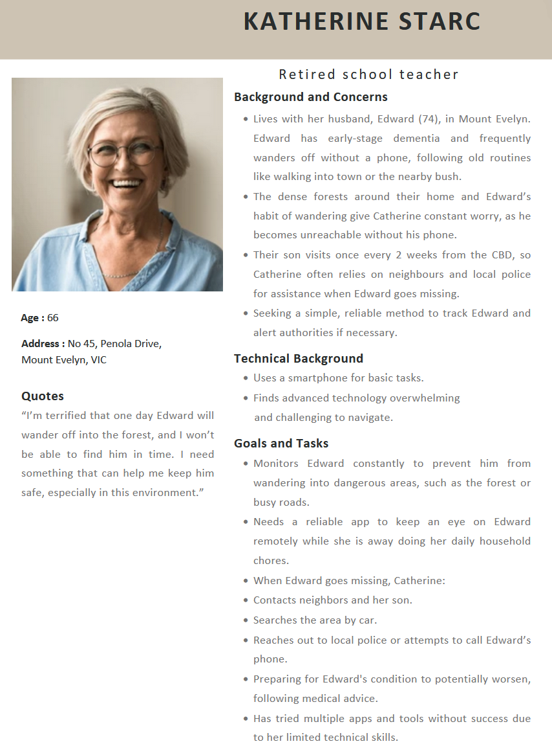

***Figure 1: A detailed User Persona model representation***

## 3.2 Flow Model

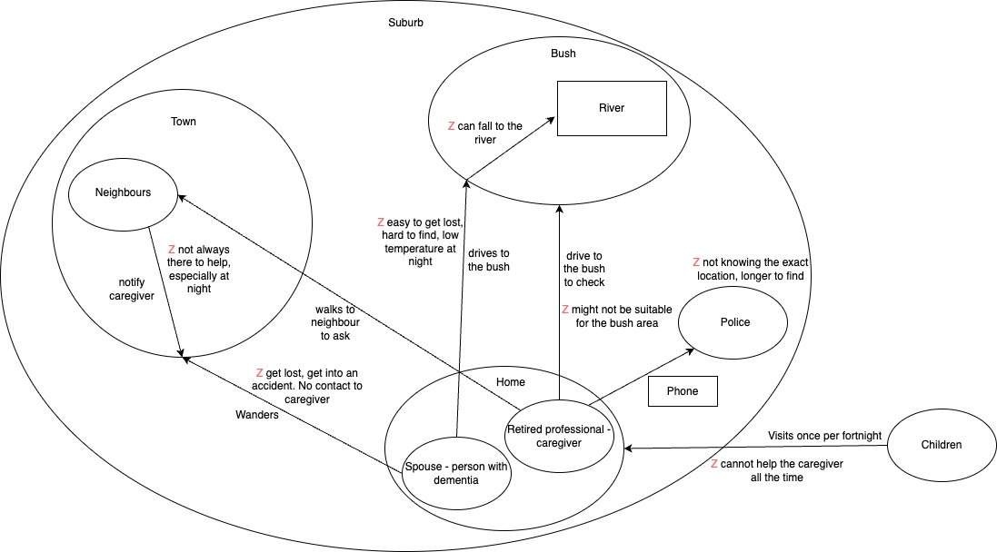

***Figure 2: A detailed Flow model representation***

3.3 Task Model

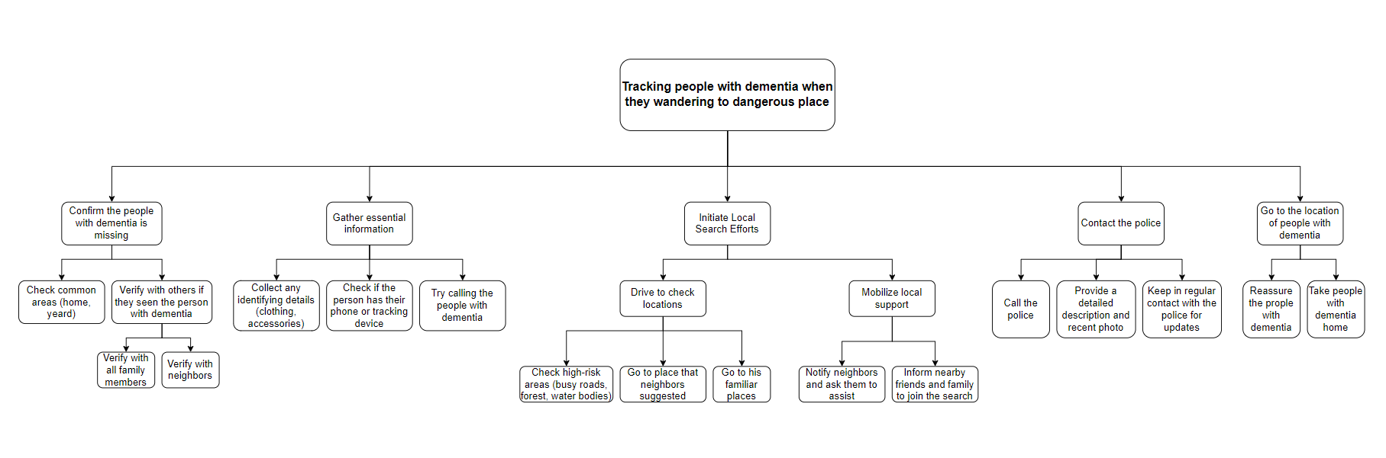

***Figure 3: A detailed Hierarchical Task Inventory (HTI) model representation***

## 3.4 Environmental Model

***Figure 4: A detailed Environmental model representation***

# **4 User Requirements**

The user interface must be accessible and simple. For this, it must include large, easily recognisable icons, high-contrast text, and simple navigation. This is necessary for elderly users or those who are inexperienced with technology. The interface should have minimal steps to complete the main functions, such as checking the location or making a call.

**4.1 Map and Zones**

**4.1.1 Map Display**

**Requirement:** The system must show a map with the current location of the person with dementia.

**Rationale:** Users shall easily monitor where the person with dementia is.

**Note:** The map can be refreshed, zoomed in, and zoomed out.

**4.1.2 Zone Setup**

**Requirement:** The user must be able to create new safe (green) and dangerous (red) wandering zones.

**Rationale:** Thisallows a user to set safe areas and dangerous wandering areas.

**Note:** Setting zones helps users quickly identify and respond to emergencies.

**4.1.3 Zone Management**

**Requirement:** The user must be able to modify or delete existing zones.

**Rationale:** Allows users to adjust zones as the person’s wandering patterns change, for better monitoring and response.

**Note:** Allows users to keep zone settings up to date.

**4.1.4 GPS tracker**

**Requirement:** The User must be able to see the exact location of person with dementia

marked on the map.

**Rationale:** This gives an accurate and instant location of a wandering person with dementia.

**Note:** This information shall be saved to be sent to the police for tracking and to the hospital to predict wandering behavioural patterns.

**4.2 Danger Notifications**

**Requirement:** User must receive a notification when the person with dementia reaches a red zone.

**Rationale:** Warns users of the dangers when people with dementia enter the red zone.

**Note:** After receiving the notification, the system must provide emergency contact options for the user.

**4.3 Making a call**

**4.3.1 Make a call to people with dementia**

**Requirement:** The User shall be able to make a call to the person with dementia, through the watch.

**Rationale:** This feature is crucial for immediate communication, especially when the person enters a potentially unsafe area, providing a quick way to reach them directly.

**Note:** The User can contactthe person with dementia as a first resort, before calling the emergency services.

**4.3.2 Make a call to an emergency contact**

**Requirement:** The User shall be able to call from a list of emergency contacts.

**Rationale:** Allows the user to quickly and efficiently contact essential services or individuals, such as the police, hospital, or other necessary contacts.

**Note:** The emergency list consists of neighbours, close family members, police and hospital.

**4.4. Monitoring and Alerts:**

**4.4.1. Battery Life Monitoring**

**Requirement:** The system must generate and send an alert to the user when the watch battery goes low.

**Rationale:** This keeps the device active and prevents missed monitoring due to a dead battery.

**Note:** This functionality is especially helpful in circumstances when the user is unable to charge the device promptly.

**4.4.2. Fall Detection:**

**Requirement:** The system must alert the user right away if a person with dementia falls or meets with an accident.

**Rationale:** People with dementia are at risk of falls and accidents, which can lead to serious injuries. Immediate alerts help users respond quickly.

**Note:** This feature must be implemented using the accelerometer sensor, a standard fitment in most smart watches.

**4.4.3. Historical Data Access**

**Requirement:** The system must collect previously wandered locations and movement information.

**Rationale:** Allows the user to analyse wandering patterns over time, helping with medical assessments.

**Note:** The collected information can be displayed as a graphical and chart-based dashboard.

**4.5. Multi-Language Support**

**Requirement:** The system shall be able to support different languages, allowing users to choose their preferred language for the User Interface.

**Rationale:** Ensures that users who are not comfortable with English can use the system comfortably.

**Note:** This is vital for inclusion, particularly in a multi-lingual community.

# **5 Discussion and Conclusion**

## 5.1 DISCUSSION

This report aimed to set in context the target users who would interact with the Wandering Detection App. Finalising the Context of Use helped with recognising and understanding the stakeholders related to this technology, their goals and the environment where they would be using it. The persona of the primary user was inspired by the interview script in which the conversation with caregivers for people with dementia was recorded. It helped in understanding more about the struggles and challenges that an average caregiver would face, which helped in designing the Flow model. This model helped in identifying possible gaps in the caregiver’s routine that the application could be deployed to improve their situation.

The Hierarchical Task Inventory (HTI) model offers significant benefits in user-centred design by breaking down complex tasks into manageable subtasks, providing a clear understanding of user goals and enabling the design of intuitive, task-focused systems.

The Environment model helps to link different parties (users and organisational bodies) and the technology, which could aid in finding ways to assist primary users in utilising the application given to them.

Conversely, while no model can capture every detail, the persona does a proficient job of identifying the common challenges caregivers might face, giving a solid foundation for understanding user needs. Even though each person’s situation might be different, the persona was a great starting point, allowing the team to keep refining and adding more details to make the app more inclusive. The Flow model provides a helpful glimpse into a person’s daily routine, encouraging the team to look at other possible scenarios and improve the design further. The HTI model, by focusing on specific tasks, gives a clear picture of user interactions, even if it doesn’t cover every possible situation. As the app's use cases and scenarios grow and change, the prototype is designed to be scalable and flexible, ready to adapt to new insights and future needs, making sure the app stays useful and focused on the users. The environment model examines both positive and negative influences that arise from the surrounding environment. It also incorporates user's opinions and the barriers they encounter in their daily lives. This model aims to provide a comprehensive understanding of how the environment impacts users and how they interact with it. By capturing both supportive and challenging aspects, the model helps in identifying areas where improvements can be made to enhance user experience and address difficulties. These models served as a good starting point in understanding more about the target audience and setting the right context of use and specific user requirements before starting off with the prototype designing on Figma.

## 5.2 CONCLUSION

The development of the Context of Use for this project highlights the needs of caregivers for individuals with dementia. The app's user interface needs to be simple and easy to use, especially for those unfamiliar with technology. Insights from this study will guide the design of the Wandering Detection App prototype.

The main goal of the app is to give caregivers a dependable tool to monitor their loved ones' safety and health. A user-friendly design aims to reduce caregiver stress and improve the well-being of both caregivers and individuals with dementia. The report's findings provide a strong basis for designing an effective prototype, focusing on simplicity, functionality, and inclusiveness to meet the needs of all users in dementia care.

# **6. Appendix**

## 6.1 LIST OF FIGURES

***Figure 1: A detailed User Persona model representation***

***Figure 2: A detailed Flow model representation***

***Figure 3: A detailed Hierarchical Task Inventory (HTI) model representation***

***Figure 4: A detailed Environmental model representation***

# **7. References**

Brown, L., & Green, M. (2021). Technology in dementia care: A review of current applications. *Journal of Health Informatics, 12*(4), 89-102.

Hickey, E. M., & Douglas, N. F. (2021). *Person-centered memory and communication interventions for dementia: A case study approach*. Plural Publishing, Inc.

Howes, J., Denier, Y., Vandemeulebroucke, T., & Gastmans, C. (2024). The ethics of electronic tracking devices in dementia care: An interview study with developers. *Science and Engineering Ethics, 30*(3), Article 17.

Ienca, M., Wangmo, T., Jotterand, F., Kressig, R. W., & Elger, B. (2018). Ethical design of intelligent assistive technologies for dementia: A descriptive review. *Science and Engineering Ethics, 24*, 1035-1055.

James, I. A., & Jackman, L. (2017). *Understanding behaviour in dementia that challenges: A guide to assessment and treatment*. Jessica Kingsley Publishers.

Lin, Q., Zhang, D., Chen, L., Ni, H., & Zhou, X. (2014). Managing elders’ wandering behaviour using sensors-based solutions: A survey. *International Journal of Gerontology, 8*, 49–55. <https://doi.org/10.1016/J.IJGE.2013.08.007>

Lin, Q., Zhang, D., Huang, X., Ni, H., & Zhou, X. (2012). Detecting wandering behaviour based on GPS traces for elders with dementia. In *2012 12th International Conference on Control, Automation, Robotics and Vision (ICARCV)* (pp. 672–677). IEEE. <https://doi.org/10.1109/ICARCV.2012.6485238>

Nguyen, T., & Lee, K. (2022). Caregiver stress and coping strategies: An examination of support systems. *Journal of Caregiving, 8*(2), 201-215.

Qiang, L., Xinshuai, L., & Weilan, W. (2018). GPS trajectories-based personalized safe geofence for elders with dementia. In *2018 IEEE SmartWorld, Ubiquitous Intelligence & Computing, Advanced & Trusted Computing, Scalable Computing & Communications, Cloud & Big Data Computing, Internet of People and Smart City Innovation (SmartWorld/SCALCOM/UIC/ATC/CBDCom/IOP/SCI)* (pp. 505–514). IEEE. <https://doi.org/10.1109/SmartWorld.2018.00111>

Robinson, L., Hutchings, D., Corner, L., Finch, T., Hughes, J., Brittain, K., & Bond, J. (2007). Balancing rights and risks: Conflicting perspectives in the management of wandering in dementia. *Health, Risk & Society, 9*(4), 389-406.

Steeman, E., De Casterlé, B. D., Godderis, J., & Grypdonck, M. (2006). Living with early-stage dementia: A review of qualitative studies. *Journal of Advanced Nursing, 54*(6), 722–738. <https://doi.org/10.1111/j.1365-2648.2006.03874.x>

Walker, R., & Patel, S. (2020). Ethical considerations in the use of surveillance technologies in healthcare. *Journal of Medical Ethics, 46*(1), 67-74.